

**Accessibility Tips for Designers**

**Last Updated:** 6/9/2018

**Author:** [Michael "Spell" Spellacy](mailto:michael.spellacy@tmp.com)

**Level A**

**Use of Color**

Don't use presentation that relies ***solely*** on color. For example, don’t say something like, “Errors in ***red*** must be fixed”.

**Captions (Prerecorded)**

Provide captions for videos with audio. **All videos must have captions**. Videos hosted on YouTube can include auto-captioning. Auto captions are not ideal, but acceptable. If better captions can be provided, then take the time to do them right. If video is self-hosted, captions must be provided to development. TMP uses Rev.com for this task. Contact [Michael Spellacy](mailto:michael.spellacy@tmp.com) for more details.

**Pause, Stop, Hide**

Provide user controls for moving content. For example, background video or auto carousels should contain pause buttons, etc. Think about other ways to control an interface *other than with a mouse*.

**Info and relationships**

Page should be logically structured. Hopefully this is self-explanatory.

**Labels or instructions**

Label elements and give instructions. For example, use ***clear labels on forms***. Labels should not be confused with **placeholder** text, which should ***only be used as advisory information***.

**Sweet Awesomeness:**

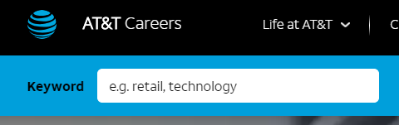

**Not Cool:**

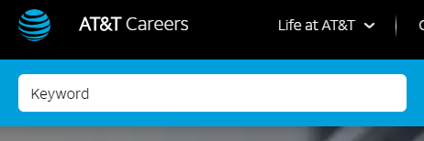

**Link Purpose (In Context)** - Every link’s purpose is clear from its *context*. For example:

**Inclusive Win:**

Request an application accommodation.

**Inclusive Fail:**

Click here to request an application accommodation.

You can easily see why one link is preferred over the other. "Click here" is not meaningful and is also ***not*** SEO friendly.

**Level AA**

**Contrast (Minimum)** - Contrast ratio between text and background is at least **4.5:1**.

**Tip 1:** Save your comps out in grayscale. If foreground text looks too light over light background, then the text likely needs to be *darkened* (or vice versa).

**Tip 2:** Use tools like **Colour Contrast Analyser** to test the contrast of your design work. Think about those with low vision or color blindness or situational circumstances, like being on a phone outdoors. Is your content readable?

<https://developer.paciellogroup.com/resources/contrastanalyser/>

**Tip 3:** Photoshop also has a way to *proof your work for color blindness*. Be sure to utilize…

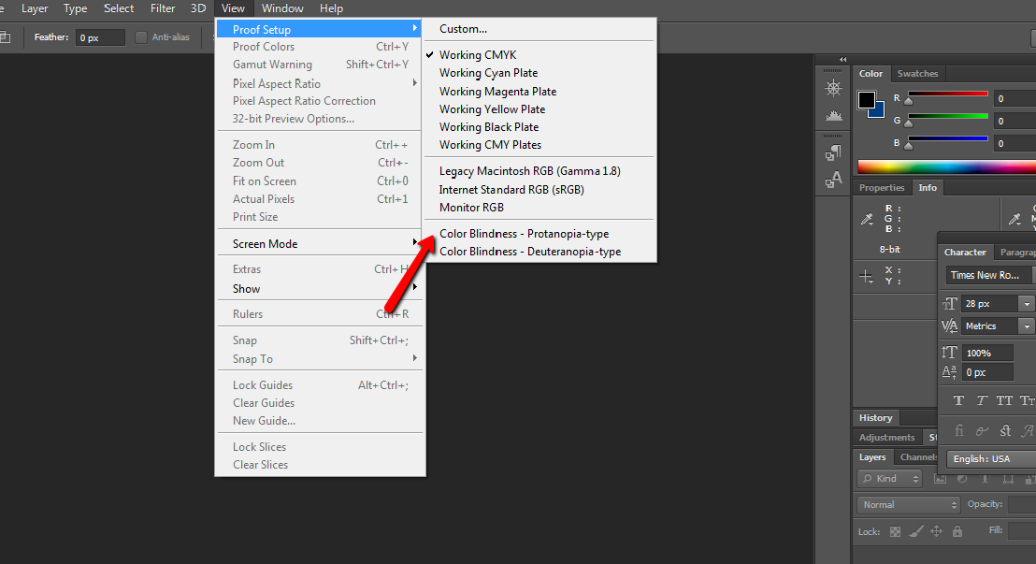

More details about this criterion can be found at <https://www.w3.org/TR/UNDERSTANDING-WCAG20/visual-audio-contrast-contrast.html>

**Images of Text**

Don’t use images of text. Logos are, of course, an exception. 😊

**Heading and labels**

Use clear headings and labels. Hopefully *this* is clear.

**Offer several ways to find pages**.

For example, be sure to design a sitemap that contains something *other than just job listings*. When technology fails us (like a navigation not working), it is good to have an alternative means to navigate the site.

**Use menus consistently**

This should be a no-brainer.